Beauty Salon Lead & Appointment Automation System
GoHighLevel | Synthflow | Voice Agents | CRM | Inbound & Outbound Automation | Email

Project Overview
Built a GoHighLevel automation system for a beauty salon to manage inbound and outbound customer calls, appointment booking, follow ups, and customer communication.
The setup connects GoHighLevel with Synthflow and organizes the complete customer journey inside the CRM.
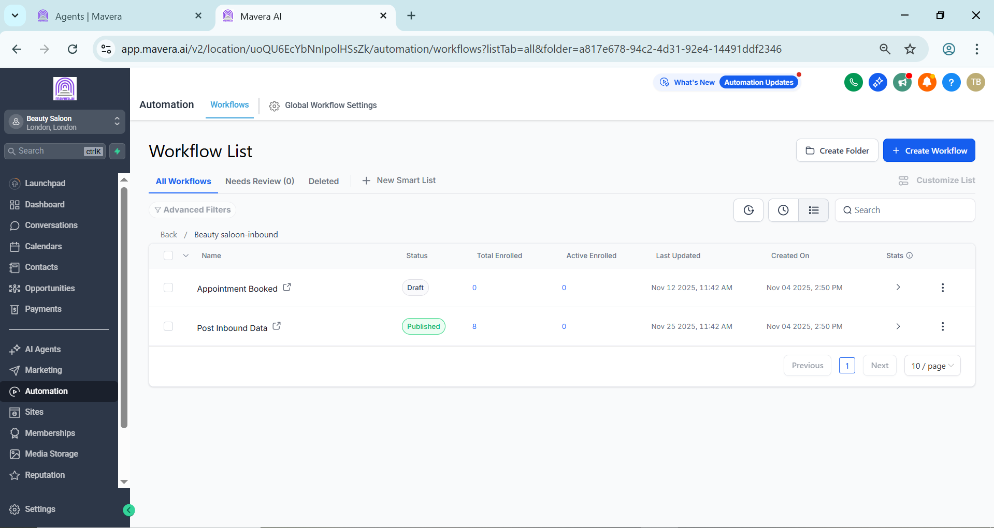
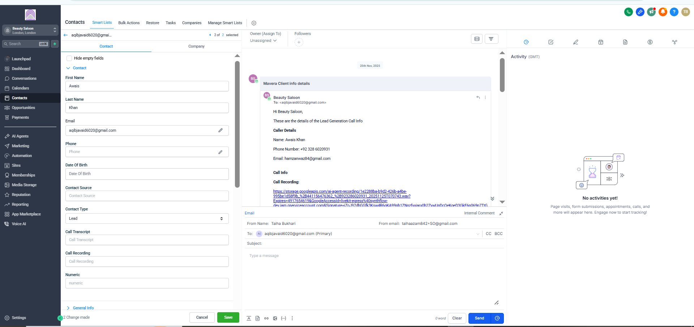
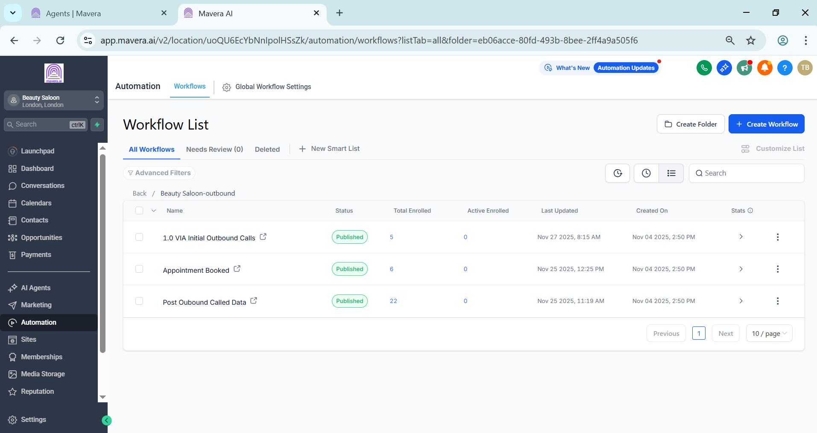
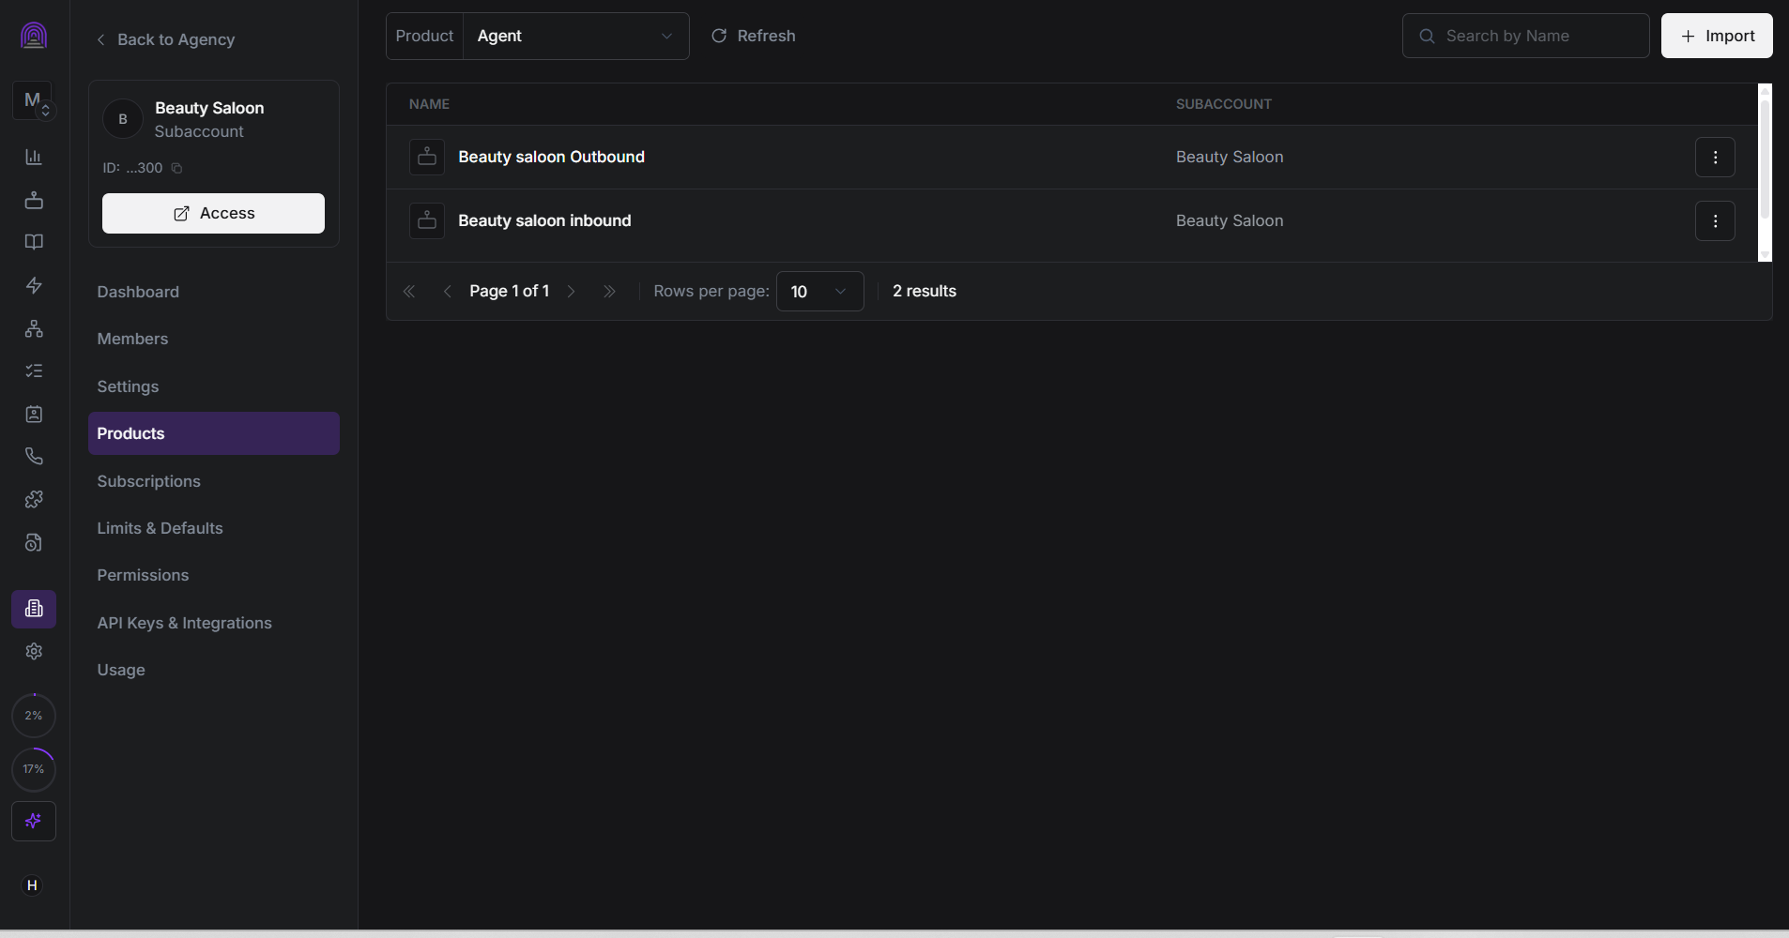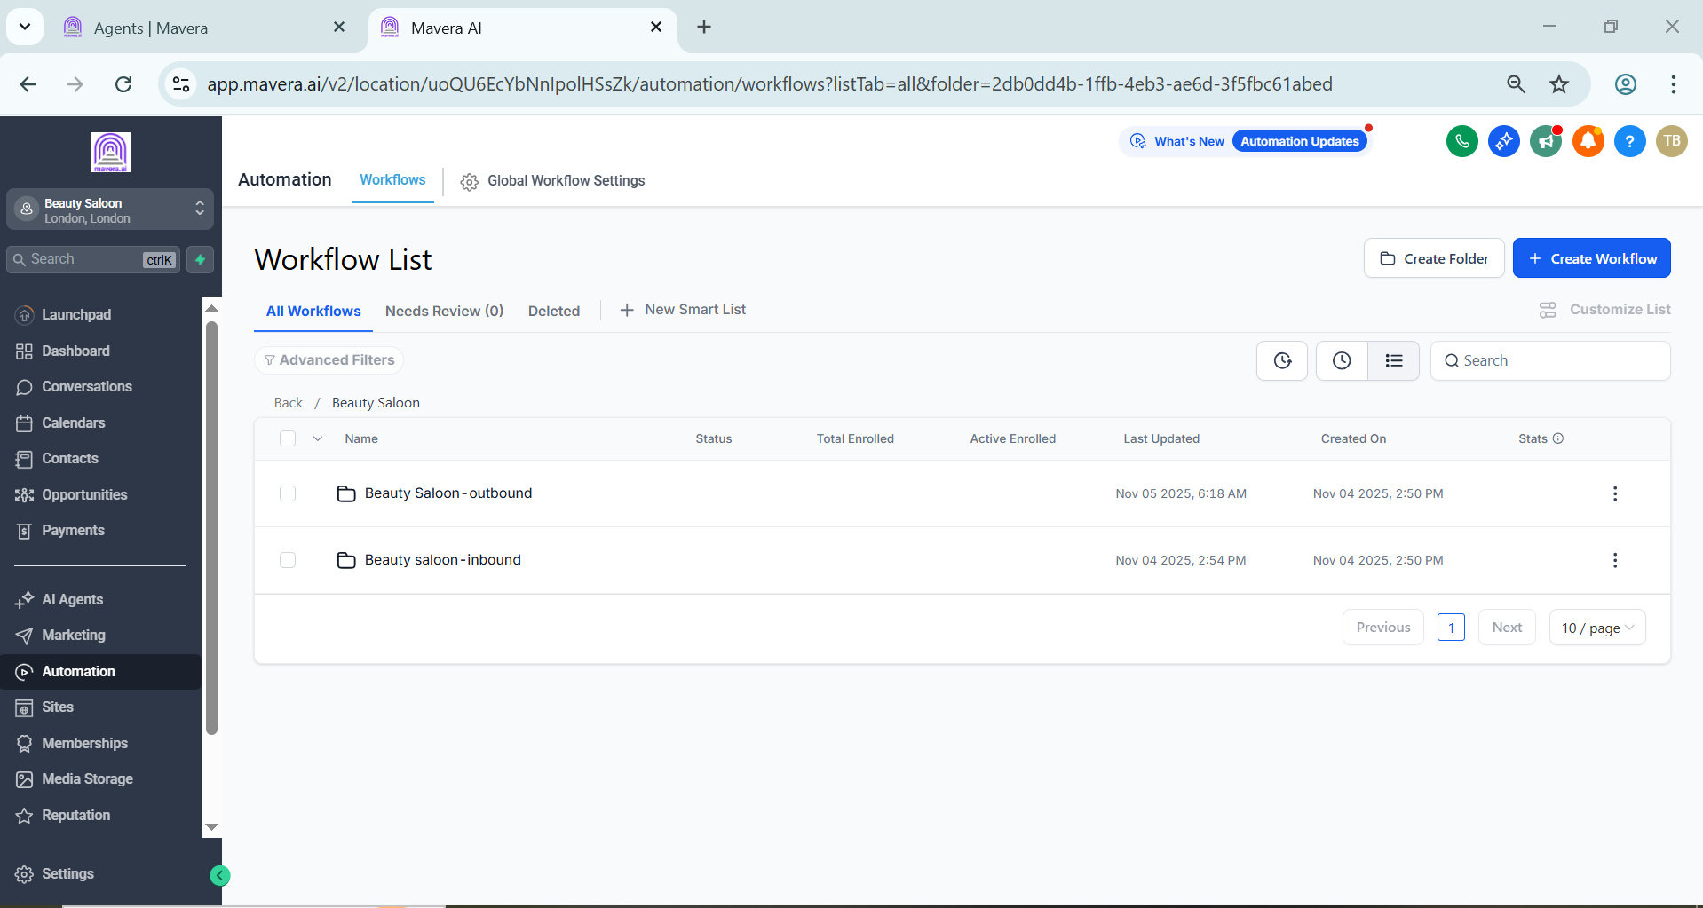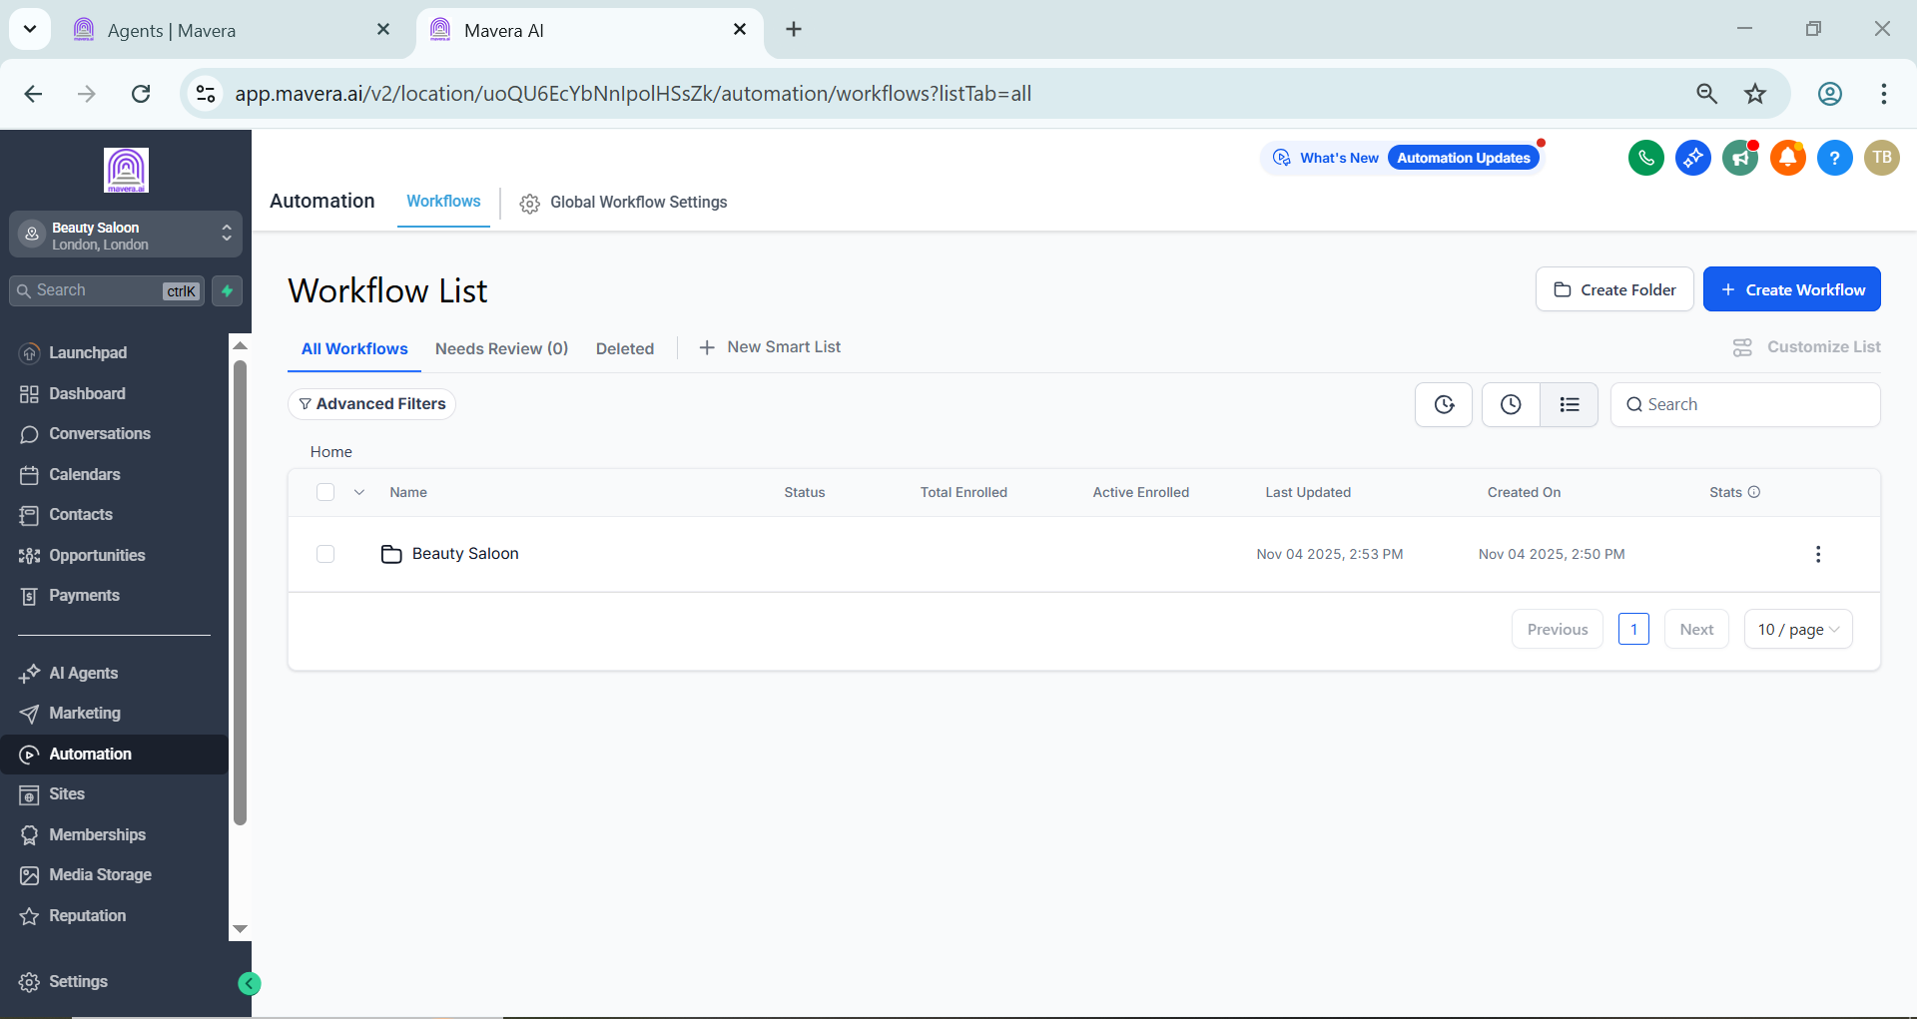

Subaccount Setup
A dedicated Beauty Salon subaccount was configured with separate workflows for:
• Inbound calls
• Outbound calls
• Appointment booking
• Post call data
• Customer follow ups

Inbound Automation
The inbound setup handles incoming customer calls and routes them through the appropriate workflow.
It includes:
• Inbound voice agent
• Appointment booking
• Post call data handling
• CRM updates

Outbound Automation
The outbound setup manages customer calls through a dedicated voice agent and separate workflows.
The process includes:
• Initial outbound calls
• Appointment booking
• Post call data processing
• CRM updates

Appointment & Email Automation
Once an appointment is booked, the customer information is updated in GoHighLevel and the required communication is triggered.
Email communication is also managed directly through the CRM, keeping customer details and follow up activity organized.

Technology
• GoHighLevel
• Synthflow
• Voice Agents
• CRM Workflows
• Appointment Booking
• Email Automation

Result
A centralized beauty salon automation system connecting inbound calls, outbound calls, appointment booking, follow ups, and customer communication inside GoHighLevel.
The setup reduces manual lead handling and provides a structured process for managing customer interactions from the initial call through appointment booking.

